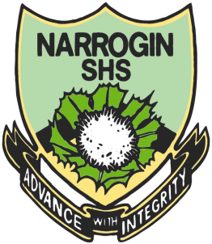

My Target: ____ / 70 or ______ % Complete on the day of the test
(Circle when your test is handed back)

Name: __ Teacher:

Yr 8 Humanities and Social Sciences:

Aboriginal Culture and Language
Total marks  /30 | % | Weight  20%

Task 5, Semester 2, Noongar Language

SECTION 2: 30 MINUTES WORKING TIME
Total Marks = 30 marks
Use your class notes (book) or the following website
http://www.noongarculture.org.au/wp-content/uploads/2013/07/Noongar-Dictionary-Second-Edition.pdf
to complete the questions below. Translate words in to Noongar.
If you can do the translation without your booklet and/or website, then have a go first!
PART 1:
Animals: (1 mark each - /15)
- Freshwater Crayfish - _____________________________

- Prawns - __________________________

- Ring tail Possum - ___________________________

- Eagle - _______________________________

- Red Tail Cockatoo - ________________________________

- Night owl - _______________________________

- Kangaroo - _____________________________

- Emu - ___________________________________

- Dolphin - ____________________________________

- Echidna - ____________________________________

- Numbat - ____________________________________

- Chuditch - _________________________________

- Dog - __________________________________

- Frog - __________________________________

- Bream - _________________________________

PART 2:
English to Noongar Body Parts: (1 mark each - /5)
- Knee - __________________________________

- Nose - __________________________________

- Head - __________________________________

- Hand - __________________________________

- Back - __________________________________
- PART 2:
- English to Noongar Body Parts: (1 mark each - /5)

Noongar word | English word | Diagram | Mark
Boorn Baal | Tree | 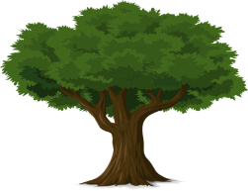
Yongka Baal |  |  | 2
 | Water |  | 2
Kaya |  |  | 2
Yabera |  |  | 2
 | Snake |  | 2
 | One |  | 2
 | Two |  | 2
 | Three |  | 2
 | Four |  | 2
 | Five |  | 2
 | Six |  | 2
 | Seven |  | 2
 | Eight |  | 2
 | Nine |  | 2
 | Ten |  | 2
Dwert Baal |  |  | 2
 | Emu |  | 2
 | Walk |  | 2
 | Head |  | 2
 | Ant |  | 2
Bunitj Baal |  |  | 2
 | Eye |  | 2
Djen Djin |  |  | 2
 | Ochre |  | 2
 | Black |  | 2
 | Camp fire |  | 2
Karla maya-maya |  |  | 2
Birl |  |  | 2
 | West |  | 2
 | Cave |  | 2
Now enter your own choice of words.
Noongar word | English | Image | Mark
 |  |  | 3
 |  |  | 3
 |  |  | 3
 |  |  | 3
 |  |  | 3

Teachers Comments.

